Submission Application
Variations of the Artist Book: Philadelphia Center for the Book Member Exhibition
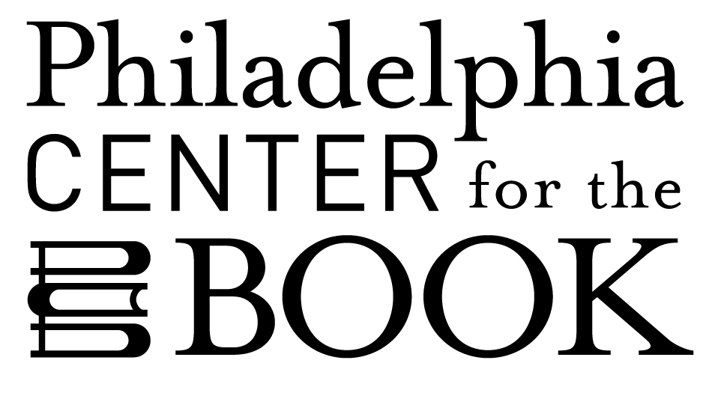

SUBMIT all materials via email to exhibitions@philadelphiacenterforthebook.org

Title of Exhibition: Variations of the Artist Book: Philadelphia Center for the Book Members Exhibition
Dates of Exhibition: September 30 – November 29, 2019
Dates of Loan: August 26 – December 4, 2019
Location of Exhibit: 2nd floor, City Hall, Market and Broad Streets, Philadelphia

Contact Information
Name: Email
Address: Street City State Zip
Phone: Website:
________________

ENTRY #1
Title: Date:
If multiple artists/writers, list:
Medium:
Size (HxWxD) when displayed:
Value:
Short statement about the piece:

_____________

ENTRY #2
Title: Date:
If multiple artists/writers, list:
Medium:
Size (HxWxD) when displayed:
Value:
Short statement about the piece:

ENTRY #3
Title: Date:
If multiple artists/writers, list:
Medium:
Size (HxWxD) when displayed:
Value:
Short statement about the piece:

ENTRY #4
Title: Date:
If multiple artists/writers, list:
Medium:
Size (HxWxD) when displayed:
Value:
Short statement about the piece:

_____________________________________

Submission Checklist
Completed application
Images of submitted pieces, up to 4 entries per member
Each labeled: last name_brief title_image number.
Short bio in a Word document

Submission applications that aren’t complete or in the required form will not be accepted for consideration.

Philadelphia Center for the Book reserves the right not to display any work that does not fit the cases (72" H x 94" W x 30" D).

Unless Philadelphia Center for the Book is notified in writing to the contrary, it is understood that this loan may be photographed and reproduced in PCB’s publications and for publicity connected with this exhibition and documented by PCB for educational use and for City Hall exhibition promotion purposes.

